**Maven project to build on jenkins and create war file**

Step :1

Create a maven project from start.spring.io as shown below

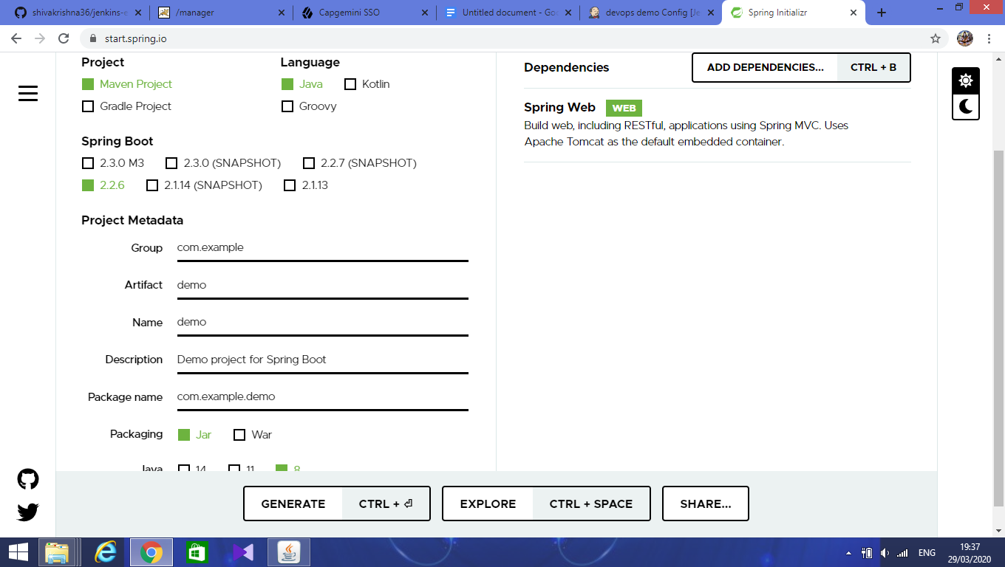

After giving details click on the generate button. It will download the zip file.

Step :2

Open that project in eclipse, create one folder WEB-INF/jsp for jsp file as shown below.

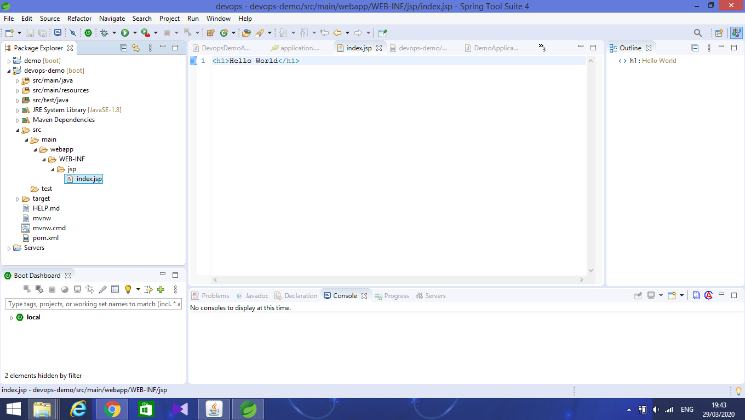

Step :3

Configure the main class as follows:

Add @controller above the class.

Add “Extends” **SpringBootServletInitializer** to main class.

Create one method which redirects the url(‘/’) to jsp page as follows

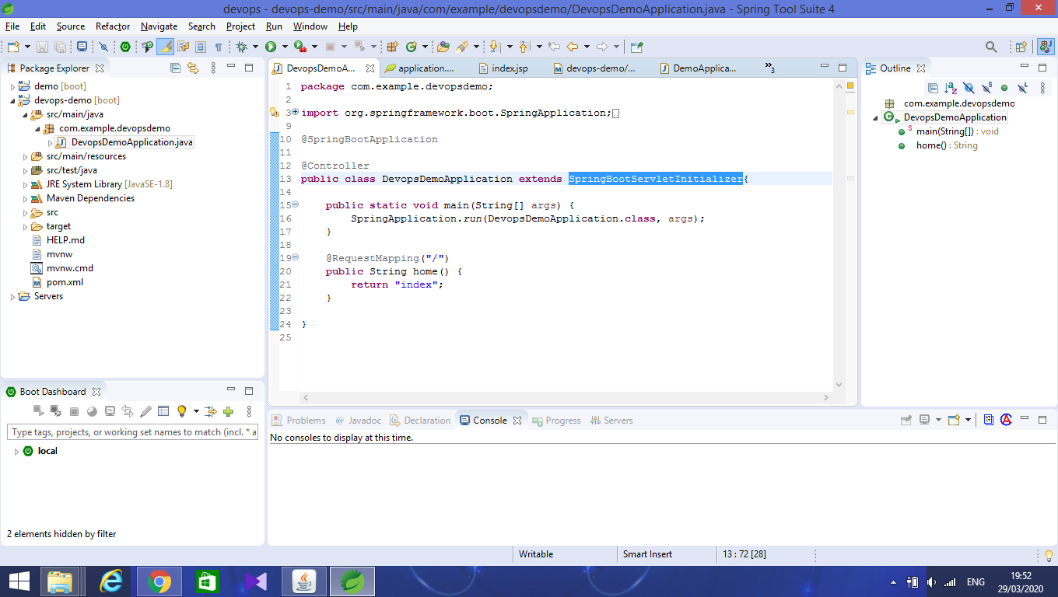

Run the program it will display the hello world on web as follows:

Type the url as http://localhost:<your port>

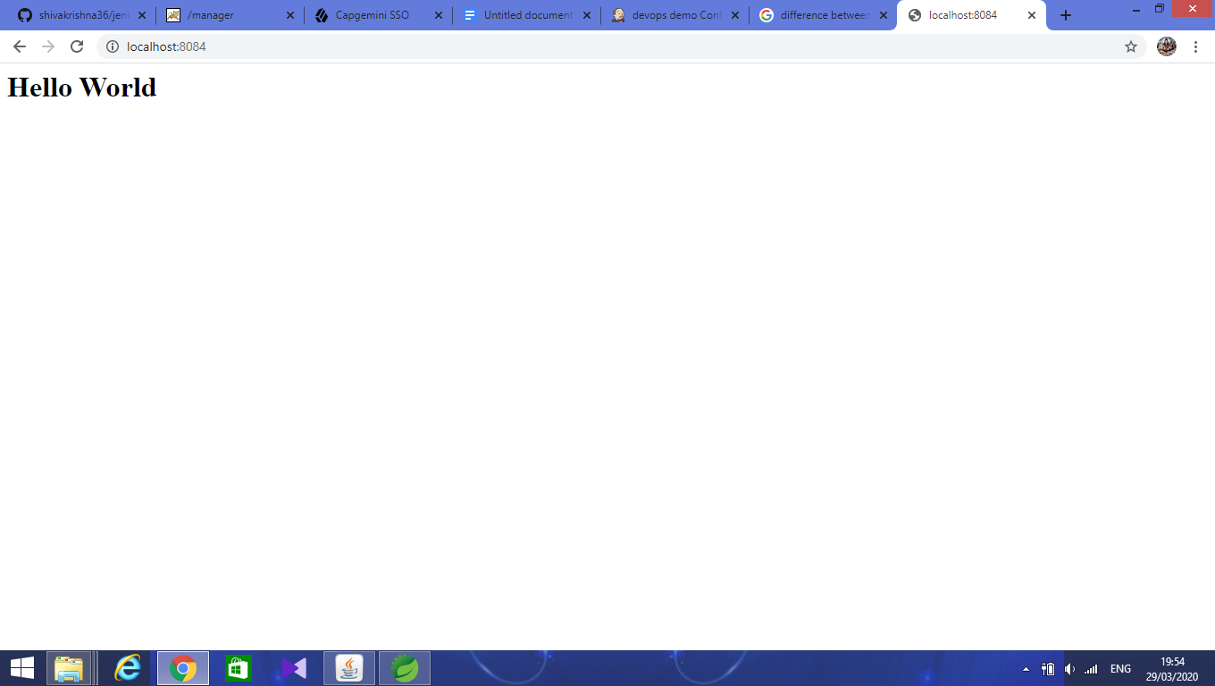

Step :4

Configure pom.xml with the dependencies as follows:

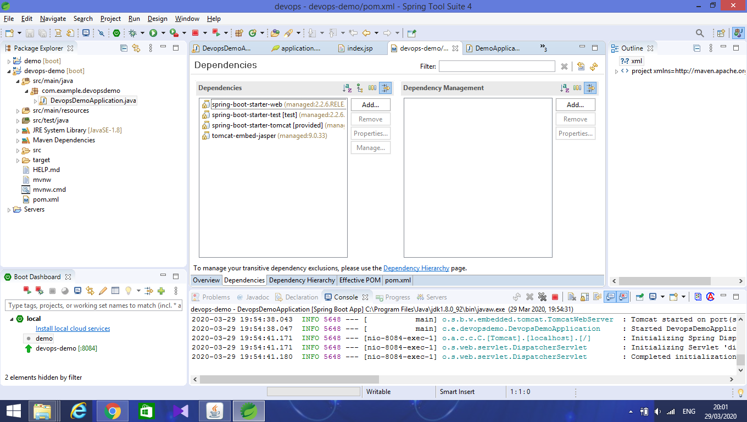

Next, push the code into the github repository.

Step 5:

Open Jenkins and create a new job for a maven project.

Enter a name for a job and select the type of project as shown:

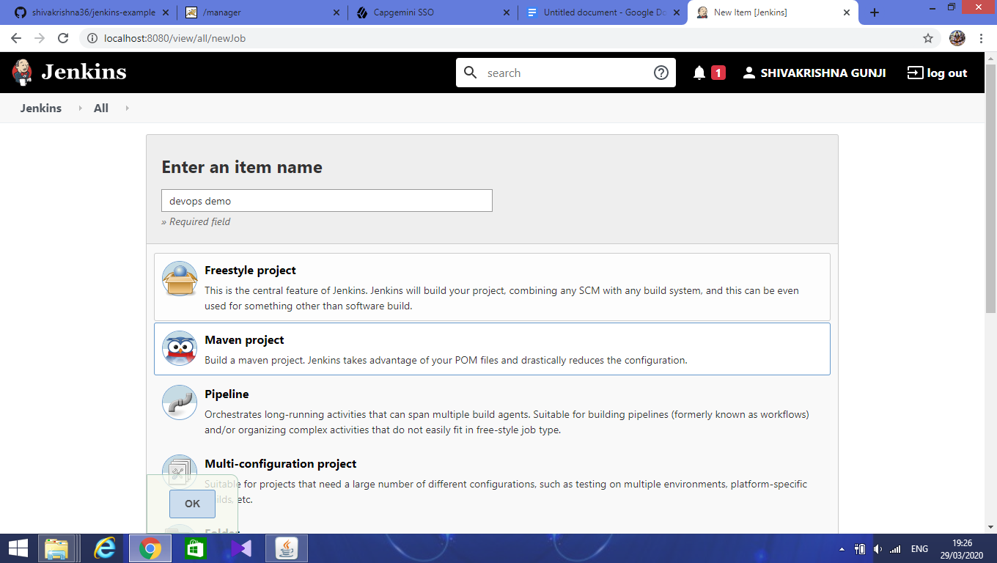

Next, configure the general details

Select github project as shown:

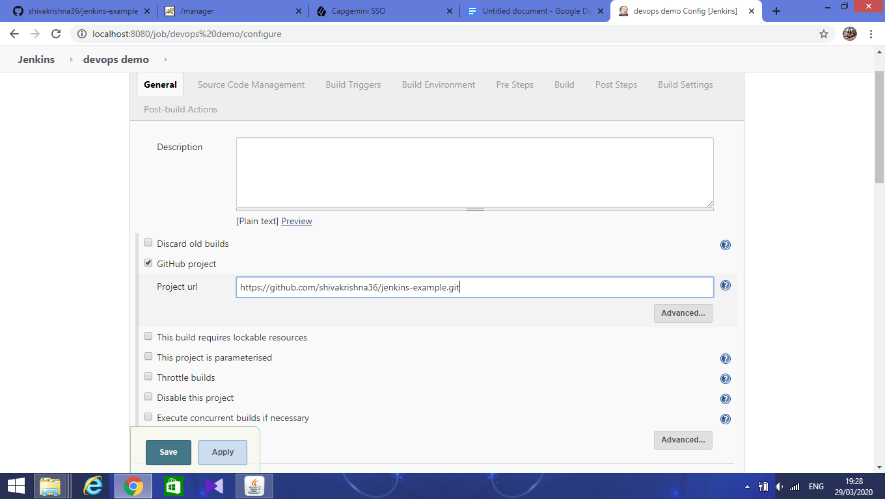

Next, Source Code Management

Select Git and give the repository url as follows:

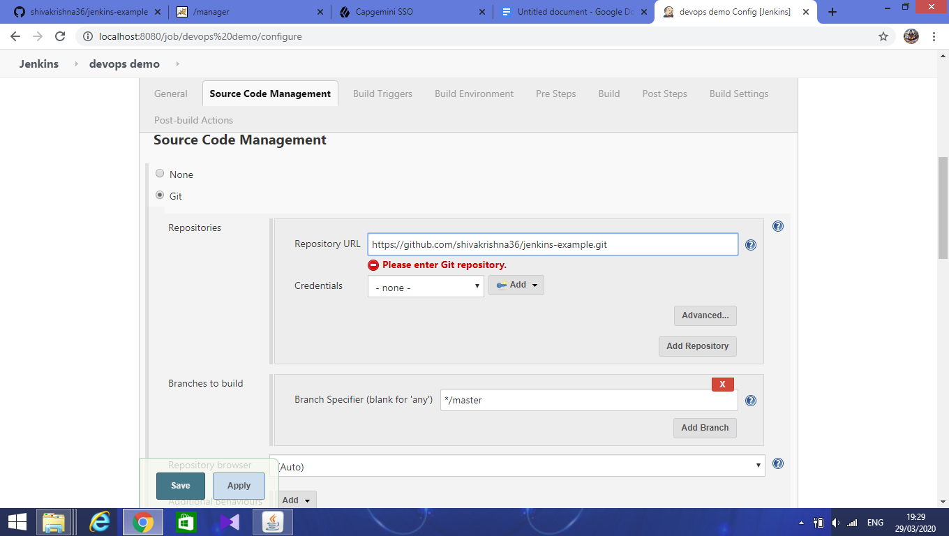

Select github hook trigger for git scm

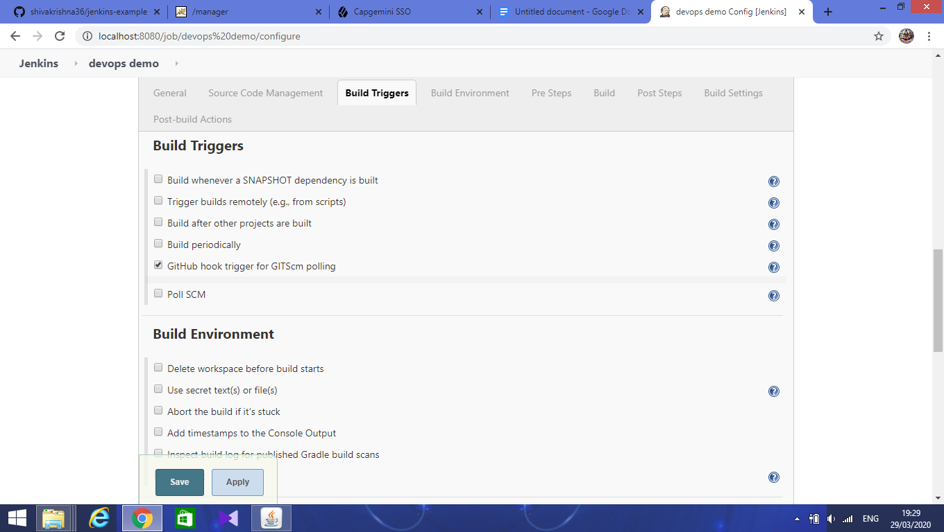

Pr-build step

Select the option ‘invoke top level maven targets’

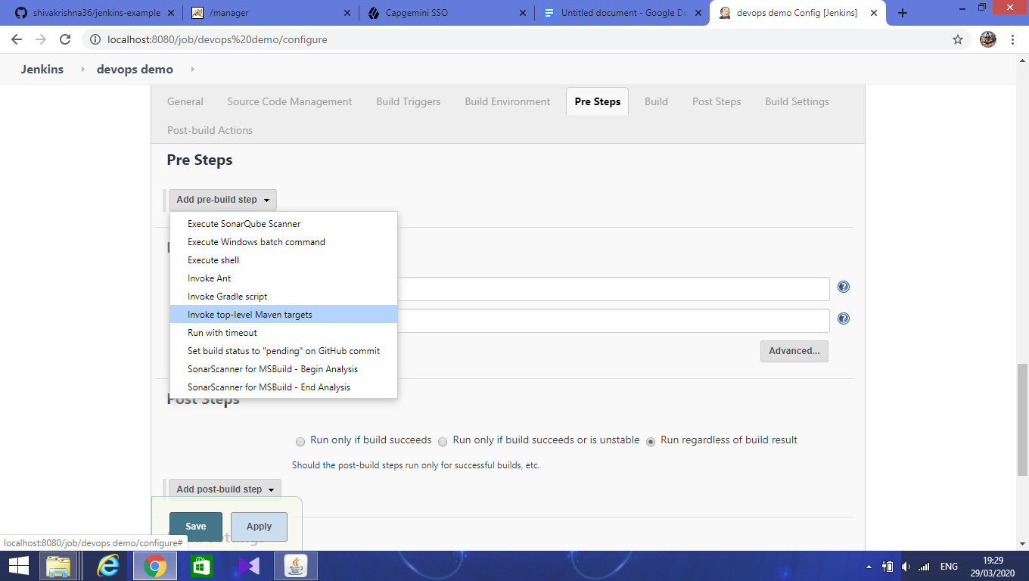

Build,

Add goals as clean and package for generating the war file

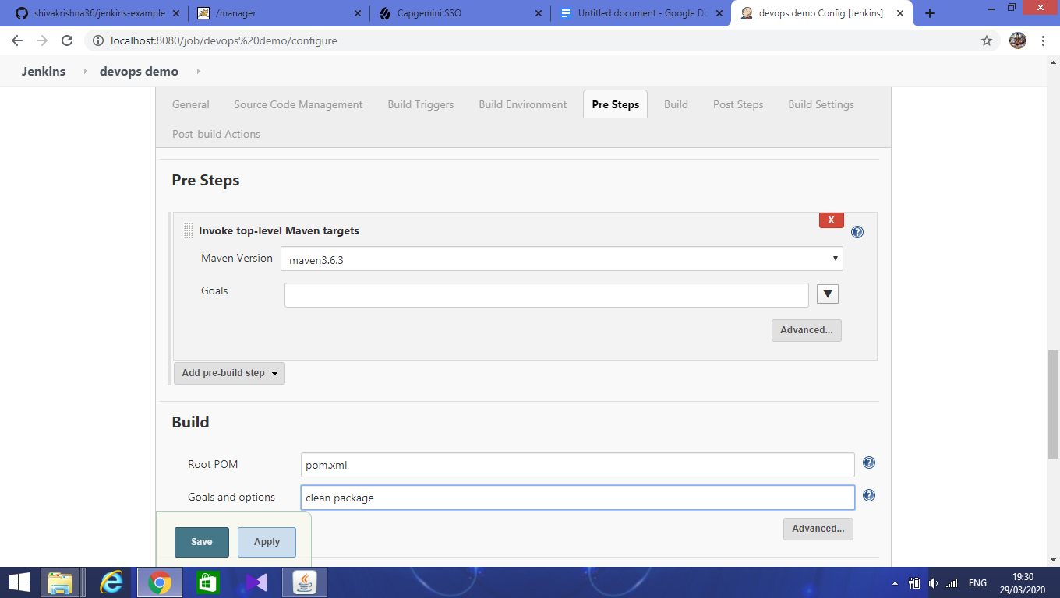

Apply and save.

Click on build now it will build the project and create the war file.

Console output

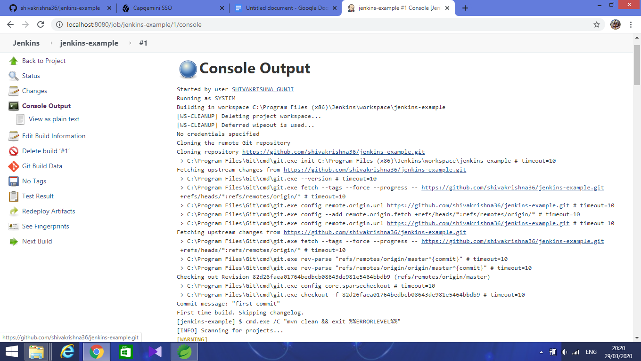

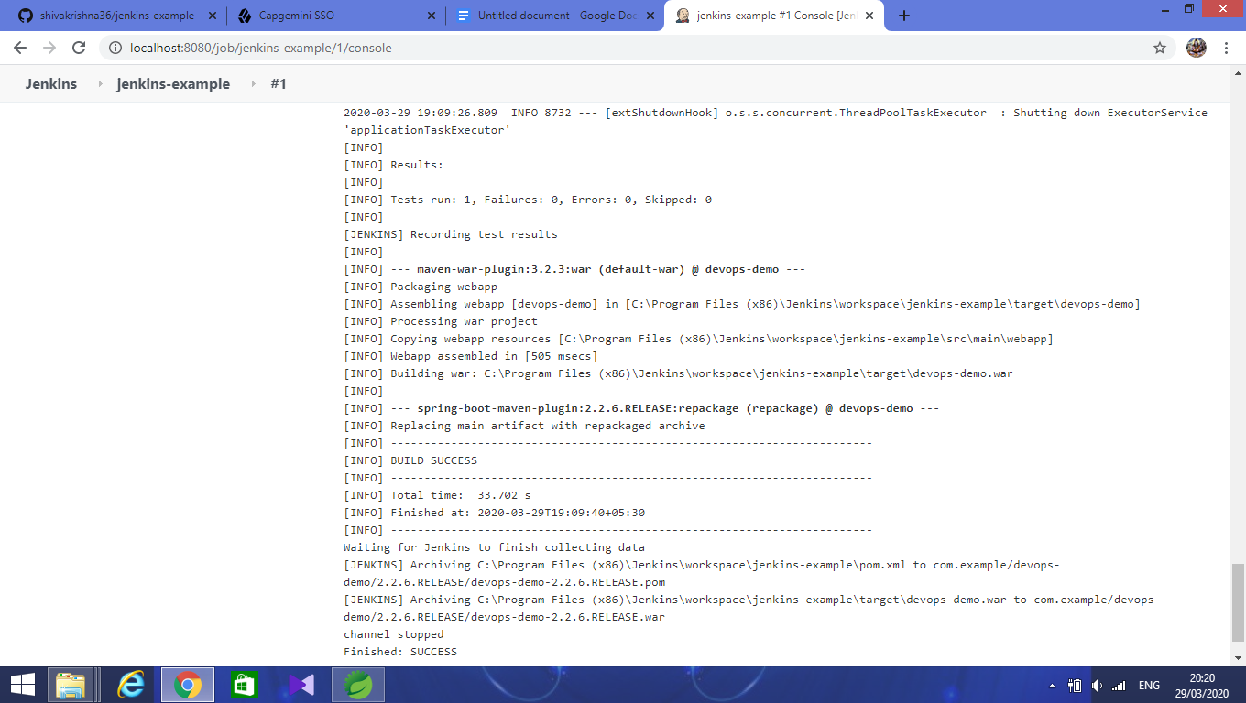

Next, open the workspace in the path “C:\Program Files (x86)\Jenkins\workspace” under the target folder you find the war file.

